Q1a).
?crabs

The crabs data frame has 200 rows and 8 columns, describing 5 morphological measurements on 50 crabs each of two colour forms and both sexes, of the species Leptograpsus variegatus collected at Fremantle, W. Australia.
Source: Campbell, N.A. and Mahon, R.J. (1974) A multivariate study of variation in two species of rock crab of genus Leptograpsus. Australian Journal of Zoology 22, 417–425.
Q1b). Loading the data and displaying its structure.
Q1c) to produce frequency table
Frequency<-table(crabs$sex)
Frequency
F M
100 100

D) to construct bar plot
barplot(Frequency,main = "Morphological Measurement of Crabs", xlab = "Sex",
ylab = "Frequency", col=c(1:2))

From Figure 1, the barplot, the sex appear to have approximately equal number of observations. This suggest that the dataset is balanced across the two sexes in the crabs dataset whichh contains 200 observations. One species does not outweight the others in frequency.
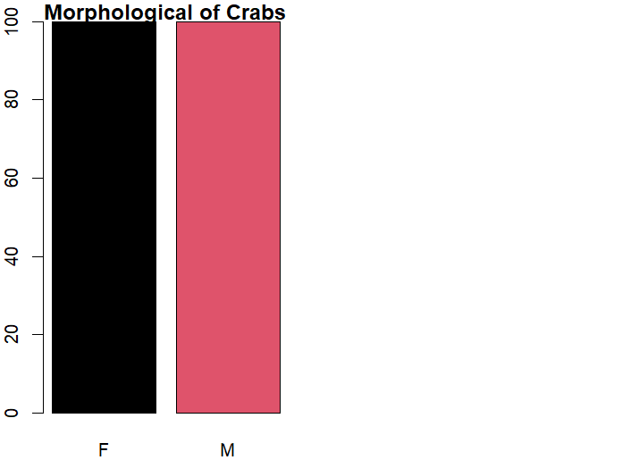
Figure 1:Morphology of crab

Q2)
par(mfrow=c(1,2))
#to construct a boxplot of body depth for the four groups
boxplot(crabs$BD~crabs$sp, data=crabs, main="SPECIES",
col=c("blue","green"))

boxplot(crabs$BD~crabs$sex, data=crabs, main="SEX",
col=c("orange","red"))

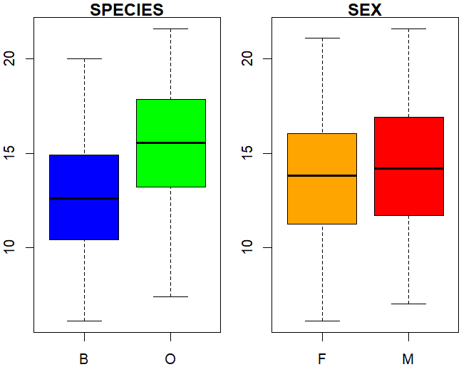
B) outliers: Male species typically shows few small outliers in body depth.
Female species generally shows no extreme outliers in this variable

Comparison: All the species have the same mean and median which show that they
distribution is symmetric
mean_O<-mean(crabs$BD[crabs$sp=="O"])
mean_B<-mean(crabs$BD[crabs$sp=="B"])
median_O <- median(crabs$BD[crabs$sp=="O"])
median_B <-median(crabs$BD[crabs$sp=="B"])

mode_O<- crabs$BD[which.max(table(crabs$BD[crabs$sp == "O"]))]
mode_B<- crabs$BD[which.max(table(crabs$BD[crabs$sp == "B"]))]
var_O<-var(crabs$BD[crabs$sp=="O"])
var_B<-var(crabs$BD[crabs$sp=="B"])

Central_values<-data.frame(
mean=c(mean_O,mean_B),
median=c(median_O, mode_B),
mode=c(mode_O,mode_B),
var=c(var_O,var_B)
)
print(Central_values)

Result
mean median mode var
1 15.478 15.55 7.7 9.931834
2 12.583 8.20 8.2 9.411930

Q3)
par(mfrow=c(1,2))

hist(crabs$CL[crabs$sp== "O"],main = "SPECIES O", xlab="lenght (cm)",
breaks = 3,
border = "white",col="darkgreen")

hist(crabs$CL[crabs$sp== "B"],main = "SPECIES B", xlab="lenght (cm)",
breaks = 3,
border = "white",col="darkred")

From figure 2, Skewness: species O is negatively skewed, species B is symmetric since it has a bell shape
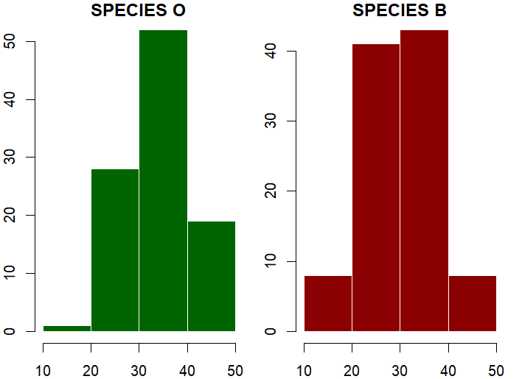
Figure 2: Bar plot
Q4)
mean
1 7.20
2 19.90
3 7.20
4 17.10
5 8.45

Q5A
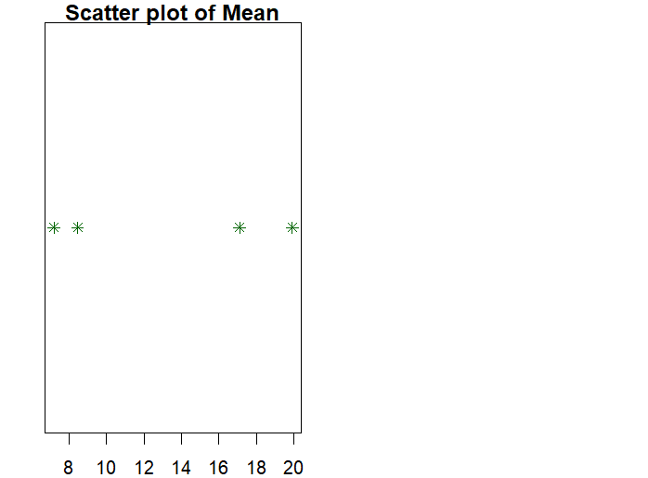

Q6)
Introduction
The crabs dataset, introduced by Campbell, N.A. and Mahon, R.J. in the year 1974,
contains morphological measurements
of two crabs species: "O", and "B."
The aim of this report is to conduct a descriptive statistical
analysis of the dataset using R and to examine
differences among species.
Analysis
The dataset contains 200 observations evenly
distributed across two species, making it
balanced for comparative analysis.
Measures of central tendency(mean) indicate that
morphological measurements does not vary substantially across species,
Conclusion
The crabs dataset does not demonstrates clear morphological separation among
the two species.

